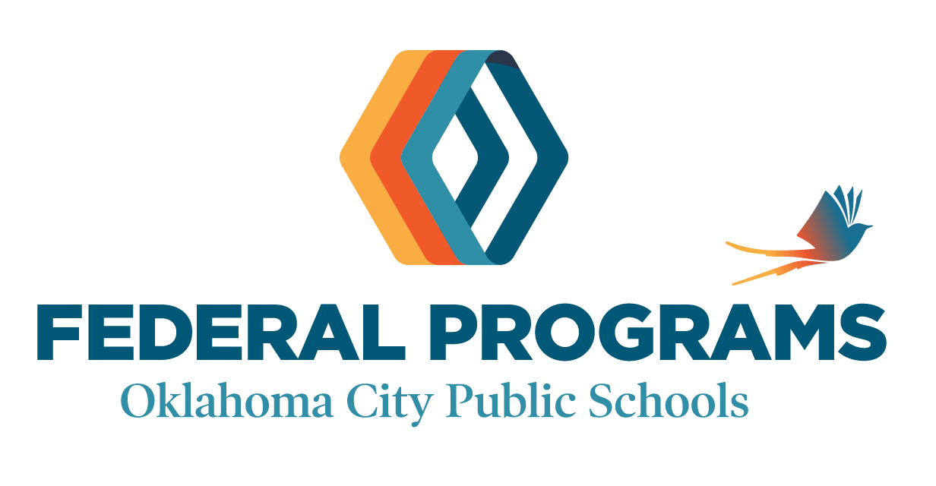

Letter for Parent’s Right to Know Regarding Teacher Qualifications

Date of Distribution: August, 2025

To Parents/Guardians of Emerson South Student,

Your child is attending a school receiving Title I federal funds through the Every Student Succeeds Act (referred to as EESA). This Federal law requires that parents be notified of their right to know the professional qualifications of their child's teacher(s) in core academic subject areas, and information on the level of achievement and academic growth of the student. This can include the following information:

- The type of state credential or license that the teacher holds. Some
teachers will have a credential in a particular subject area, such as English
or mathematics, and others will have a multiple subject credential, which
allows them to teach a variety of subjects, such as in elementary schools.
- The education level and subject area of the teacher’s college degree(s). All teachers have a bachelor’s degree, and many teachers have graduate degrees beyond the bachelor’s, such as a master's or doctoral degree. In addition to the qualifications of the teacher, if a paraprofessional (teacher’s aide) provides your child services, you may also request information about his or her qualifications. Many paraprofessionals have two years of college, and others have passed a test that verifies their qualifications.
- If the teacher is teaching in a field of discipline within the certification of the teacher.
- Information on the level of achievement and academic growth of the student, if available, on each of the State academic assessments.

If you would like this information, please contact the building principal.

Thank you,

Gina Villalva, Principal of Emerson South Mid High School

